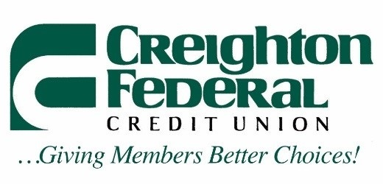

Request for Certificate Of Deposit

NO PENALTY for early withdrawals as long as minimum balance is maintained.
(This does not include IRAs).

Primary Name on CD_____________________________________________________

Joint Owner (s) __________________________________________________________

Beneficiary______________________________________________________________

Phone _______________________ E-Mail Address _____________________________

Account #____________________________ Amount $__________________________

Term Requested __________________ months Certificate Type: IRA__ Share ______

Funds to come from: Savings ___ Checking ___ Money Market __ Check Enclosed ___

Signature____________________________________________ Date_______________

Handling Instructions for CD Request

Please indicate your CD preference by filling in all information requested above. Then:

Mail signed request with copy of valid ID to:
Creighton Federal Credit Union
Attn: New Accounts
2575 Dodge Street
Omaha, NE 68131
-OR-
FAX signed request with copy of valid ID to:
(402)341-6262
Attn: New Accounts
-OR-
Email scanned and signed request with copy of valid ID to:
newaccts@creightonfederal.org
-OR-
You may drop-off your request at any of our convenient locations.

Please be sure that the request is filled out completely. If you have any questions, please call any of our locations for assistance. An application without a valid signature by all owners of the CD will be considered void. Creighton Federal will acknowledge having received the application via phone or email.

Employee Initials ______

